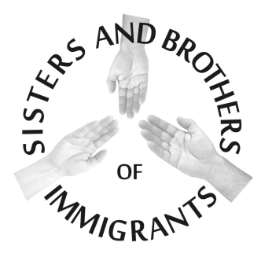

**Commitment to Novena of Prayer and Fasting: June 13-21, 2016**

**For the Supreme Court Ruling and Comprehensive Immigration Reform**

***“Whatever you did for one of these least brothers and sisters of mine, you did for me.” (Matt 25:40)***

Please send to Sr. Rose Therese Nolta ,SSpS by June 22 or before to [jpicssps@yahoo.com](mailto:jpicssps@yahoo.com) Thank You!

We, the following members of (Congregation) ______________________________, commit ourselves to prayer and fasting during the Novena on June _______________ for the Supreme Court, for the elimination of the raids, for a friendly spirit toward refugees, for mothers and children who are forced to escape danger in their home countries, as well as for Comprehensive Immigration Reform. Our government needs to address the injustice of confinement to detention centers, deportation policies, and border control procedures. In addition, we must focus on giving immigrants a path to citizenship, keeping families together, and addressing the root causes of migration.